MAT092 with ALEKS Weekly Quiz Schedule
Quizzes are on paper and must be taken during or prior to your regular classroom meeting during the scheduled week. No late or makeup quizzes will be given. The lowest quiz score will be dropped. All quizzes will contain 5 questions.
Week |  | Pie Slice | Topics for Quiz
Sept. 12 – 16  Whole Numbers - Module # 1 | Quiz # 1 | Whole Numbers | Rounding and Ordering  Introduction to inequalities  Order of Operations and Arithmetic Properties  Introduction to parentheses  Order of operations: Problem type 1  Order of operations: Problem type 2  Order of operations with whole numbers and exponents  Introduction to evaluating an algebraic expression  Introduction to properties of addition  Introduction to properties of multiplication  Understanding the distributive property
Sept. 19 – 23  Fractions - Module # 2 | Quiz # 2 | Fractions & Proportions | Equivalent Fractions  Introduction to ratios  Equivalent fractions  Simplifying a fraction  Ordering Fractions  Fractional position on a number line  Plotting fractions on a number line  Ordering fractions  Addition and Subtraction  Addition or subtraction of fractions with the same denominator  Introduction to addition or subtraction of fractions with different  denominators  Addition or subtraction of fractions with different denominators
Sept. 26 – 30  Fractions - Module # 3 | Quiz # 3 | Fractions & Proportions | Multiplication and Division  The reciprocal of a number  Product of a unit fraction and a whole number  Product of a fraction and a whole number  Introduction to fraction multiplication  Fraction multiplication  Word problem with fractions  Division involving a whole number and a fraction  Fraction division  Mixed arithmetic operations with fractions
Oct. 3 – 7 | Quiz # 4  Prop&Percent - Module # 4 | Fractions & Proportions | Proportion  Finding unit rates  Solving a proportion: Basic  Simple word problem on proportions  Word problem on proportions: Problem type 1  Percent  Introduction to percent  Converting between percentages and decimals  Converting a percentage to a fraction  Converting a fraction to a percentage  Percentage of a whole number
Oct. 11 – 14  Percent - Module # 5 | Quiz # 5 | Decimals & Percents | Percent  Writing a ratio as a percentage  Applying the percent equation  Word problem on percentage: Problem type 1  Word problem on percentage: Problem type 2  Word problem on percentage: Problem type 3  Simple interest
Oct. 17 – 21  Measurement - Module # 6 | Quiz # 6 | Measurement | Measurement  Choosing customary measurement units  Conversions involving measurements in feet and inches  Adding customary units of length  Customary unit conversion with whole number values  Customary unit conversion with mixed number values  Customary area unit conversion with whole number values  Choosing metric measurement units  Metric distance conversion with whole number values  Metric mass or capacity conversion with whole number values  Metric distance conversion with decimal values  Metric conversion with decimal values, two-step conversion  Metric area unit conversion with decimal number values  Converting between temperatures in Fahrenheit and Celsius
Oct. 24 – 28  *MIDTERM EXAM WEEK*  Geometry - Module # 7 | Quiz # 7 | Geometry | Geometry  Area of a triangle  Identifying parallelograms, rectangles, and squares  Perimeter of a square or a rectangle  Perimeter of a polygon  Perimeter and area on a grid  Distinguishing between area and perimeter  Area of a square or a rectangle  Area of a parallelogram
Oct. 31 – Nov. 4  Geometry - Module # 8 | Quiz # 8 | Geometry | Geometry  Introduction to circle: diameter, radius, and chord  Circumference of a circle  Circumference and area of a circle  Volume of a solid made of unit cubes  Volume of a cube or a rectangular prism  Volume of a cylinder
Nov. 7 – 10  Integers - Module # 9 | Quiz # 9 | Variable Expressions & Polynomials | Integers  Writing a signed number for a real-world situation  Plotting integers on a number line  Ordering integers  Plotting rational numbers on a number line  Absolute value of a number  Operations with absolute value  Integer addition: Problem type 1  Integer addition: Problem type 2
Nov. 14 – 18  Integers - Module # 10 |  | Variable Expressions & Polynomials | Integers  Integer subtraction: Problem type 1  Integer subtraction: Problem type 2  Integer subtraction: Problem type 3  Word problem with addition or subtraction of integers  Integer multiplication and division  Mixed arithmetic operations with integers  Simple addition and subtraction of signed fractions  Simple addition and subtraction of signed decimals  Signed decimal addition
Nov. 21 – 23  Variable Expr - Module # 11 | Quiz # 11 | Variable Expressions & Polynomials | Variable Expressions  Evaluation of a linear expression in two variables  Evaluation of a polynomial in one variable  Distributive property: Basic  Distributive property: Advanced  Combining like terms: Basic  Combining like terms: Advanced  Combining like terms in a quadratic expression  Writing simple variable expressions  Writing a mathematical expression
Nov. 28 – Dec. 2  Exponents - Module # 12 | Quiz # 12 | Variable Expressions & Polynomials | Exponents and Scientific Notation  Introduction to exponents  Writing expressions using exponents  Powers of 10: Positive exponent  Exponents and integers: Problem type 1  Exponents and integers: Problem type 2  Exponents and signed fractions  Exponents and order of operations
Dec. 5 – 9  Poly&Eqns - Module # 13 | Quiz # 13 | Variable Expressions & Polynomials AND Equations & Graphs | Polynomials  Simplifying a sum or difference of polynomials  Simplifying a polynomial expression  Additive and Multiplicative Properties of Equality  Additive property of equality with whole numbers  Additive property of equality with decimals  Additive property of equality with fractions  Additive property of equality with integers  Additive property of equality with a negative coefficient
Dec. 12 – 16 | Quiz # 14  Equations - Module # 14 | Equations & Graphs | Additive and Multiplicative Properties of Equality  Multiplicative property of equality with whole numbers  Multiplicative property of equality with signed fractions  Multiplicative property of equality with integers  Solving Linear Equations  Solving a two-step equation with integers  Solving a two-step equation with signed fractions  Solving a linear equation with several occurrences of the variable:  Problem type 3  Applications of Linear Equations  Translating sentences into equations

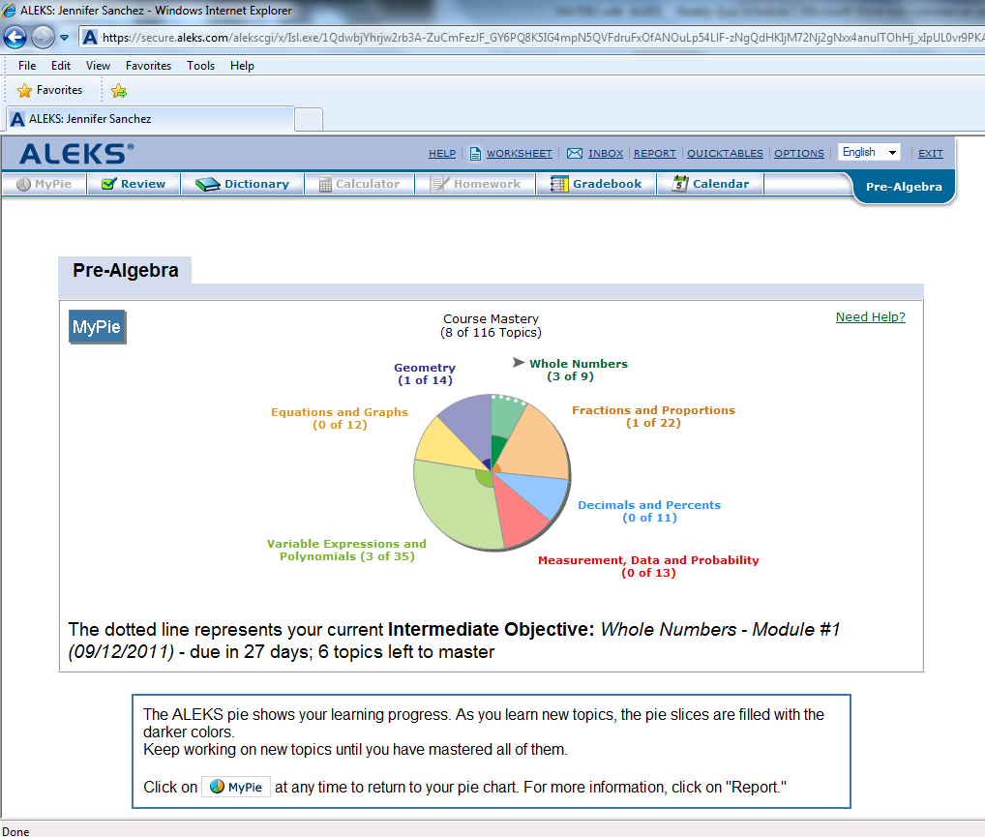
Always work in the pie slice(s) with the white dotted line

