MAT091 with ALEKS Weekly Quiz Schedule
Quizzes are on paper and must be taken during or prior to your regular classroom meeting during the scheduled week. No late or makeup quizzes will be given. The lowest quiz score will be dropped. All quizzes will contain 5 questions.
Week |  | Pie Slice | Topics for Quiz
Sept. 12 – 16  Whole Numbers - Module # 1 | Quiz # 1 | Whole Numbers | Expanded Form and Numeral Translation  Whole number place value: Problem type 1  Whole number place value: Problem type 2  Expanded form  Expanded form with zeros  Numeral translation: Problem type 1  Numeral translation: Problem type 2  Addition and Subtraction  Single digit addition with carry  Addition of 3 or 4 single-digit numbers  Adding a 2-digit number and a 1-digit number with carry  Addition without carry  Addition with carry  Addition with carry to the hundreds place  Addition of large numbers  Adding or subtracting 10, 100, or 1000  Subtracting a 1-digit number from a 2-digit number  Subtraction without borrowing  Subtraction with borrowing  Subtraction with multiple regrouping steps  Subtraction and regrouping with zeros  Word problem using addition or subtraction
Sept. 19 – 23  Whole Numbers - Module # 2 | Quiz # 2 | Whole Numbers | Multiplication and Division  Multiplication as repeated addition  One-digit multiplication  Multiplication by 10, 100, and 1000  Multiplication without carry  Multiplication with carry  Introduction to multiplication of large numbers  Multiplication with trailing zeros: Problem type 1  Multiplication with trailing zeros: Problem type 2  Multiplication of large numbers  Simple division  Division without carry  Division with carry  Division with trailing zeros: Problem type 1  Division with trailing zeros: Problem type 2  Division involving quotients with intermediate zeros  Quotient and remainder: Problem type 1  Word problem on quotient and remainder  Quotient and remainder: Problem type 2  Quotient and remainder: Problem type 3  Word problem using division  Basic word problem using multiplication or division  Word problem with multiple operations  Rounding and Ordering  Introduction to inequalities  Ordering large numbers  Rounding to tens or hundreds  Rounding to hundreds or thousands  Rounding to thousands, ten thousands, or hundred thousands  Estimating a sum  Estimating a difference  Estimating a product or quotient
Sept. 26 – 30  Whole Numbers - Module # 3 | Quiz # 3 | Whole Numbers | Order of Operations and Arithmetic Properties  Introduction to parentheses  Introduction to order of operations  Order of operations: Problem type 1  Order of operations: Problem type 2  Order of operations with whole numbers and exponents  Factors and Prime Numbers  Divisibility rules for 2, 5, and 10  Divisibility rules for 3 and 9  Factors  Prime numbers  Prime factorization  Greatest common factor  Least common multiple
Oct. 3 – 7 | Quiz # 4 | Fractions | Equivalent Fractions  Introduction to fractions  Understanding equivalent fractions  Equivalent fractions  Introduction to simplifying a fraction  Simplifying a fraction
Oct. 11 – 14  Fractions - Module # 5 | Quiz # 5 | Fractions | Ordering and Plotting Fractions  Ordering fractions with same denominator  Ordering fractions with same numerator  Ordering fractions  Fractional position on a number line  Plotting fractions on a number line
Oct. 17 – 21  Fractions - Module # 6 | Quiz # 6 | Fractions | Addition and Subtraction  Addition or subtraction of fractions with the same denominator  Addition and subtraction of simple unit fractions  Introduction to addition or subtraction of fractions with different  denominators  Addition or subtraction of fractions with different denominators  Fractional part of a circle
Oct. 24 – 28 | Quiz # 7 | Fractions | Multiplication and Division  The reciprocal of a number  Product of a unit fraction and a whole number  Product of a fraction and a whole number  Introduction to fraction multiplication  Fraction multiplication
Oct. 31 – Nov. 4  Fractions - Module # 8 | Quiz # 8 | Fractions | Multiplication and Division  Word problem with fractions  Division involving a whole number and a fraction  Fraction division  Complex fractions without variables: Problem type 1  Mixed arithmetic operations with fractions
Nov. 7 – 10  Fractions - Module # 9 | Quiz # 9 | Fractions | Mixed Numbers  Writing a mixed number and an improper fraction for a shaded region  Writing an improper fraction as a mixed number  Writing a mixed number as an improper fraction  Addition or subtraction of mixed numbers with same denominator  Addition of mixed numbers with same denominator and carry
Nov. 14 – 18  **Midterm**  Fractions - Module # 10 | Quiz #10 | Fractions | Mixed Numbers  Subtraction of mixed numbers with same denominator and borrowing  Addition or subtraction of mixed numbers with different  denominators  Mixed number multiplication: Problem type 1  Mixed number multiplication: Problem type 2  Mixed number division
Nov. 21 – 23  Decimals - Module # 11 | Quiz # 11 | Decimals, Proportion, and Percent | Decimal Place Value and Ordering  Writing a decimal and a fraction for a shaded region  Tenths and hundredths decimal place value  Decimal place value  Rounding decimals  Introduction to ordering decimals  Ordering decimals  Ordering fractions and decimals  Conversion Between Fractions and Decimals  Introduction to writing a decimal as a fraction  Converting a decimal to a fraction  Introduction to converting a fraction to a decimal  Converting a fraction to a terminating decimal  Converting a fraction to a repeating decimal  Converting a decimal to a mixed number  Converting a mixed number to a decimal
Nov. 28 – Dec. 2  Decimals - Module # 12 | Quiz # 12 | Decimals, Proportion, and Percent | Addition and Subtraction  Addition of aligned decimals  Decimal addition  Subtraction of aligned decimals  Word problem with one decimal operation: Problem type 1  Word problem with one decimal operation: Problem type 2  Estimating a decimal sum or difference  Multiplication and Division  Multiplication of a decimal by a power of ten  Multiplication of a decimal by a whole number  Decimal multiplication: Problem type 1  Decimal multiplication: Problem type 2  Word problem using decimal addition and multiplication  Division of a decimal by a power of ten  Division of a decimal by a whole number  Decimal division  Word problem with powers of ten  Word problem using decimal subtraction and division
Dec. 5 – 9  Percent - Module # 13 | Quiz # 13 | Decimals, Proportion, and Percent | Percent  Introduction to percent  Converting between percentages and decimals  Converting a percentage to a fraction  Converting a fraction to a percentage  Percentage of a whole number  Word problem on percentage: Problem type 1

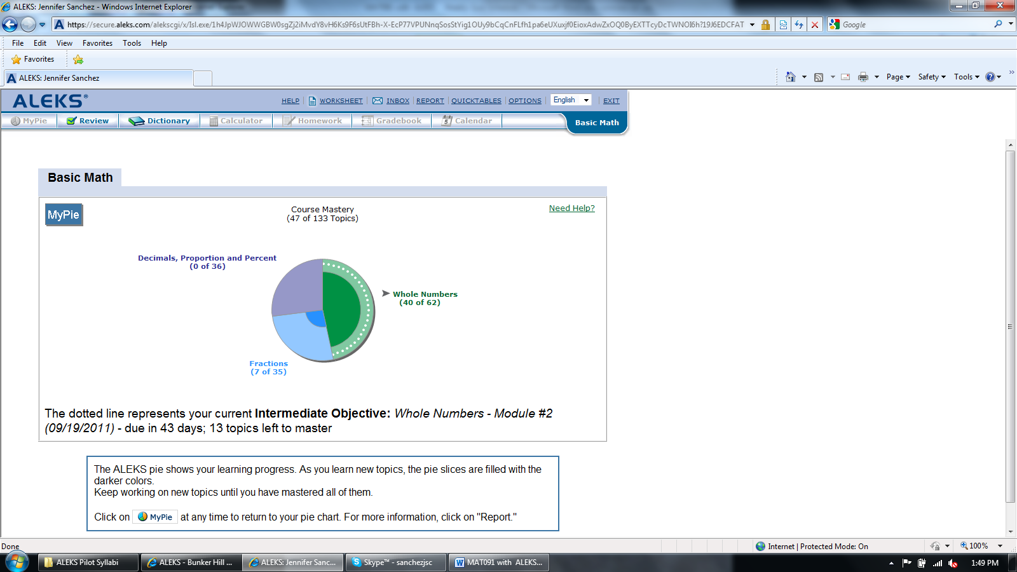
Always work in the pie slice with the white dotted line

