To move a student who has finished the starting course to the next course: 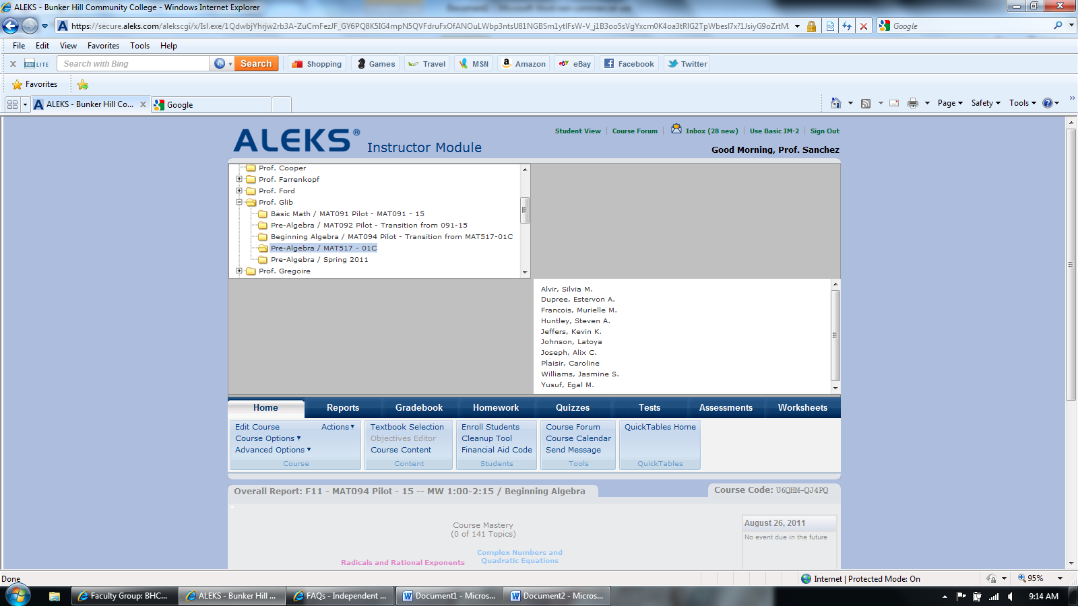

1. Click on the course in which the student is currently enrolled



2. Click “Use Basic IM-2”

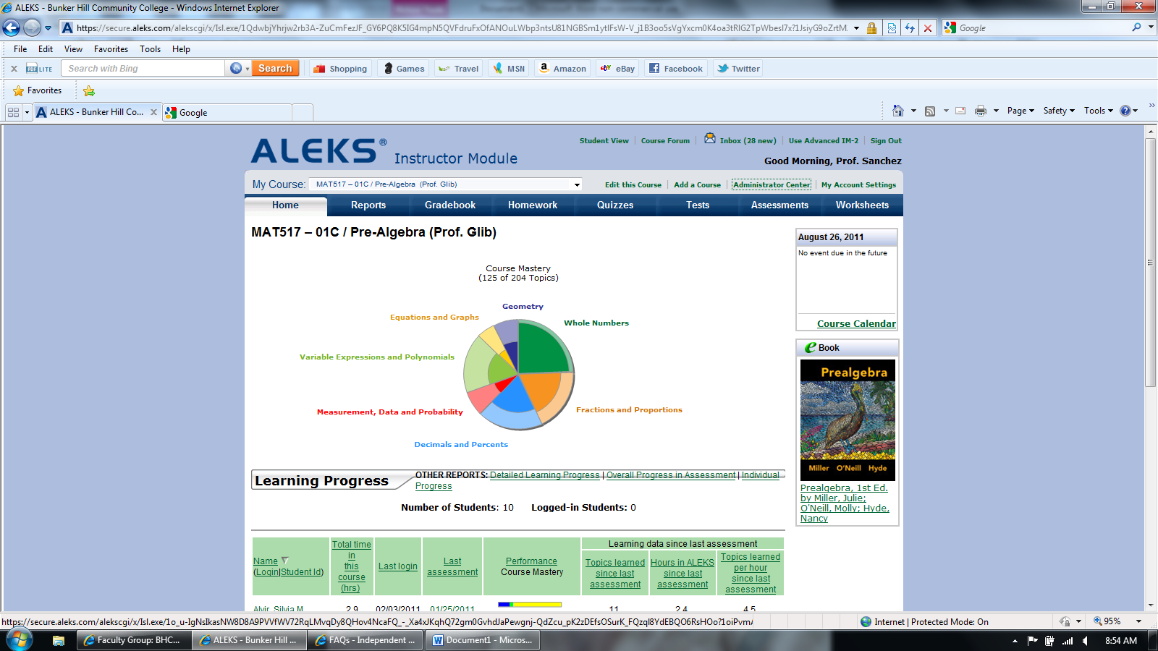

3. Click “Administrator Center”

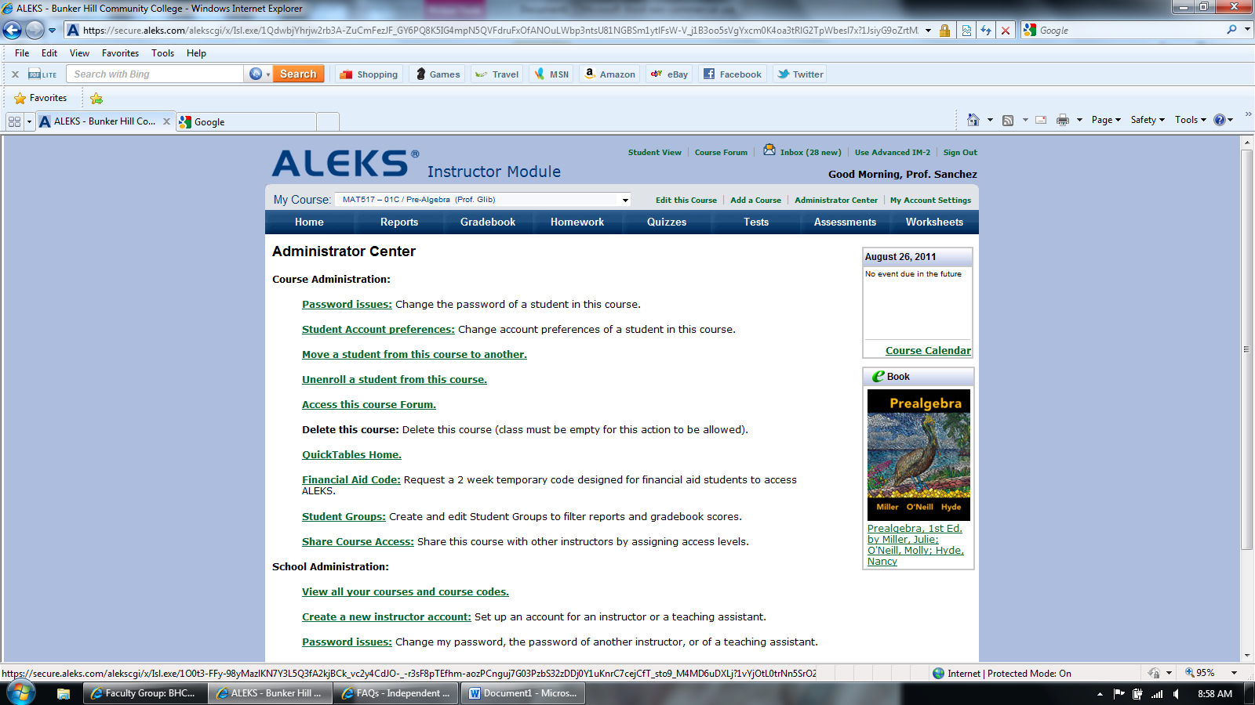

4. Click “Move a student from this course to another”

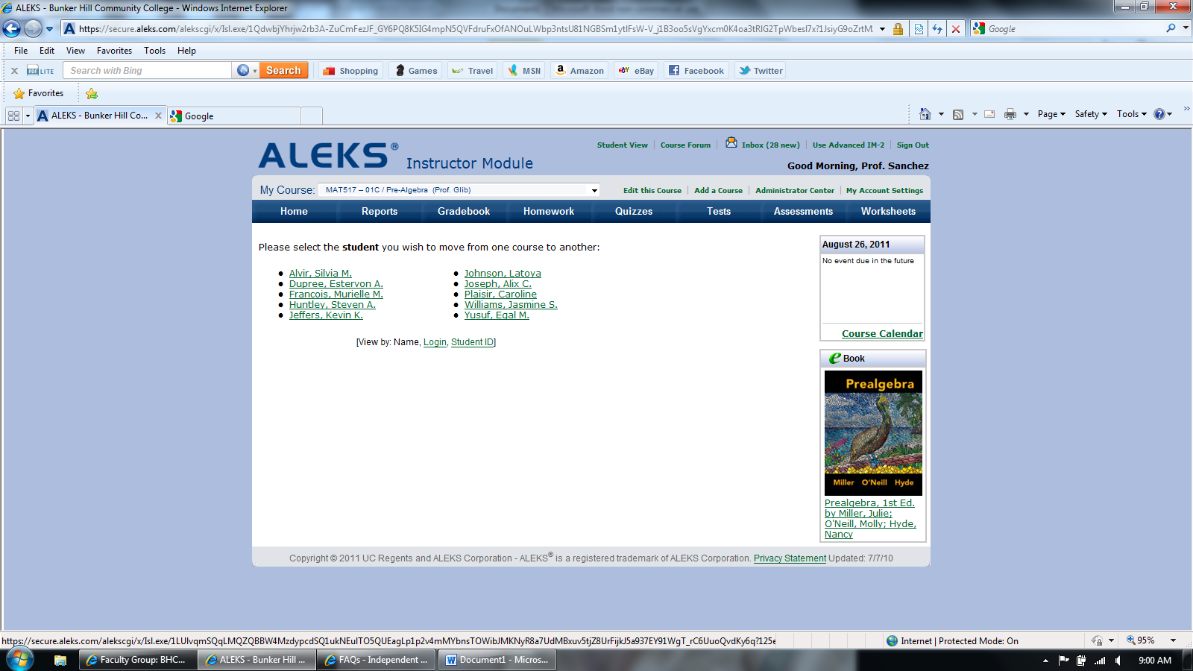

5. Click the name of the student to be moved

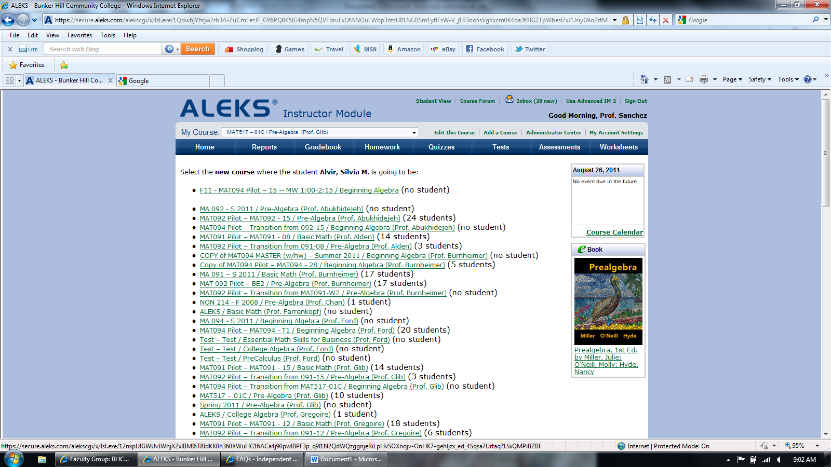

6. Select the new course for the student

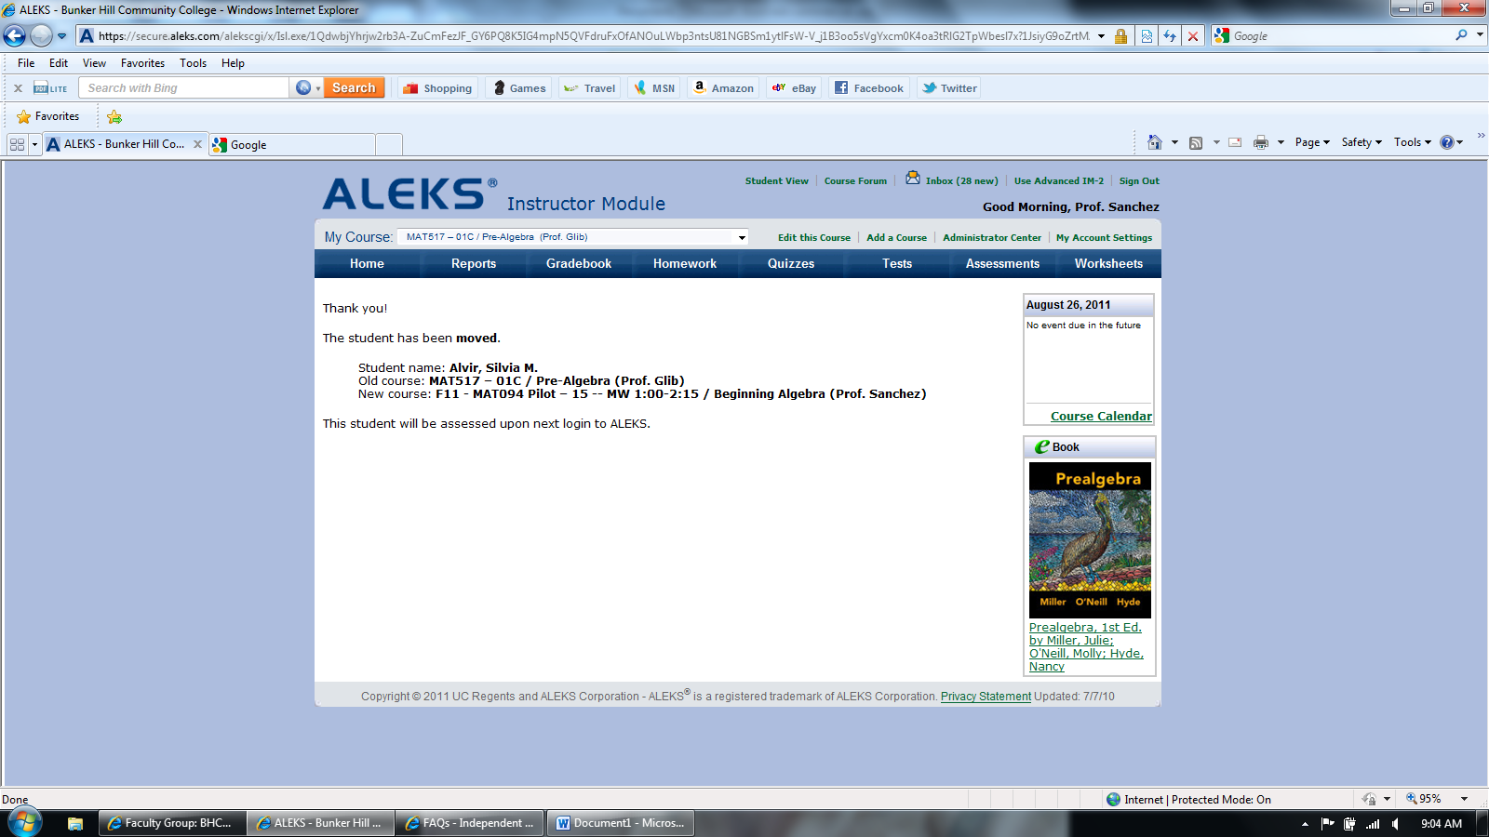

The student is now enrolled in the new course.